3m - VHB Range

Comments from Customer:
Parafix, a select distributor & converter made the following comments regarding 3m's product range:
- Quality and variety of range is very good
- MOQ: One log roll (special status as they are converters)
- Lead Times: Standard items: 2-3 days, Non standard items: 2-3 weeks
- Service could always be improved, but is the best tape supplier
- Branding: All packaging is branded.
3m printed core. Liners not printed
- Packaging: White branded boxes (3m, product and VHB range all marked on box)
2 items per box

Minimum order quantity: From the 3m web site it appears that all VHB products have a minimum order quantity of one carton

From the 3m web site, it appears that there are 22 products in the main VHB range:

3m Documents
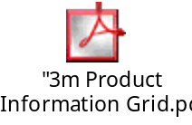 | 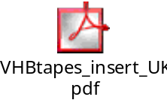 |  | 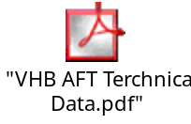 | 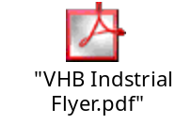

3m have many OEM approvals and is recognised as the industry standard. This will be a big challenge to overcome when launching & marketing the AFT range

Experience has shown that 3m, when threatened, re-number existing products with a new code and then reduce the market price by up to 50%

VHB Range
Products | Physical Properties |  |  |  |  | Product Description and Application Suggestions
Products | Liner | Tape Thickness mm | Colour
VHB™+
4936 | P | 0.64 | Grey | These products are conformable dark grey acrylic foam tapes with a plasticiser resistant adhesive; in addition the adhesive composition makes the 3M VHB™+ tapes ideal for many paints including powder coated paints and improve the 3M VHB™performance on some plastics particularly polycarbonate. Due to improved conformability a more complete bond contact area is attained. 4943 and 4957 are conformable tapes with a low temperature acrylic adhesive which allows initial applications to be made at temperatures as low as 0°C.
4941 | P | 1.1 | Grey
4956 | P | 1.55 | Grey
4943 | F · | 1.14 | Grey
4957 | F · | 1.57 | Grey
VHB™
4930 | P/F | 0.64 | White | Firmer acrylic foam cores combined with long ageing acrylic adhesives, provide these products with exceptional peel strengths.  Thicker versions of 4950 provide improved wet out of rigid materials and compensate for surface mismatch.
4950 | P/F | 1.1 | White
4912 | F · | 2.0 | White
4959 | F · | 3.0 | White
4929 | F · | 0.64 | Black | Black version of the 4930 and 4950 tapes where colour is required for aesthetics.
4949 | F · | 1.1 | Black
9460 | P | 0.05 | Clear | These products are clear 3M VHB adhesive transfer tapes with high shear strength and high temperature performance.
9469 | P | 0.13 | Clear
9473 | P | 0.25 | Clear
4905 | P/F | 0.5 | Clear | These products are clear acrylic tapes and are ideal for bonding transparent materials or for applications where a coloured bond line is unacceptable.  The range of thicknesses make the clear products ideal for resin filled glass manufacture.
4910 | P/F | 1.0 | Clear
4915 | F · | 1.5 | Clear
4918 | F · | 2.0 | Clear
4945 | P/F | 1.1 | White | 4945 is resistant to migration of many plasticisers and should be evaluated for applications requiring bonding to flexible plastics and to powder coated paints.
4932 | P | 0.6 | White | These products have been specifically developed for adhesion to low surface energy plastics such as polypropylene and polystyrene while maintaining excellent adhesion to metals, glass and high surface energy plastics.
4952 | P | 1.1 | White
4951 | F · | 1.1 | White | 4951 utilises a low temperature acrylic adhesive which allows initial application at 0°C. At room temperature it offers better tack/quick stick than other 3M VHB™ tapes.

(*)
"Max. cont." = for long term exposure (days,weeks)
"Max." = only short term exposure (minutes, hours)
Above values are not recommended for specification purposes.

Threats from 3m
3m dominance is far reaching across many markets
3m innovation & market development has them solidly entrenched as the 'expert leader'.
Current VHB customers are very happy
Failure of other suppliers has solidified 3m's position an discouraged VHB users from switching.
Current VHB users may leverage Scapa top get better pricing from 3m

Info from Scapa USA
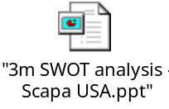 | 